**APP-Server**

**How to restart the MSSQL services**

1. Win+r
2. Type services.msc
3. 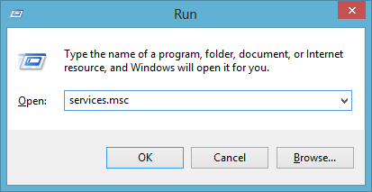
4. Press S then Select SQL Server (MSSQLSERVER)
5. 
6. Right Click and Select Restart
7. 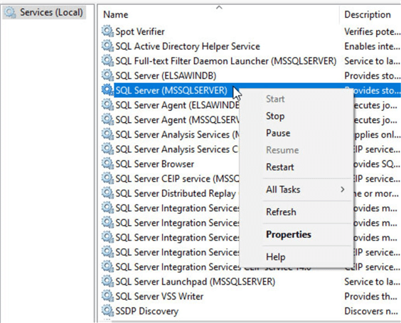
8. Pop-up coming just click **OK**